Project report

On

*THIS PROJECT PARTIALLY FULFILLMENT OF AWARDED*

*IN COMPUTER SCIENCE AND ENGINEERING,*

*SUBMITTED BY SECOND YEAR CSE*

*STUDENTS, APRIL, 2019.*

*MCKV INSTITUTE OF ENGINEERING*

*( LILUAH, HOWRAH)*

*ACKNOWLEDGEMENT*

The satisfaction that accompanies that the successful completion of any task would be incomplete without the mention of the people whose ceaseless co-operation made it possible whose constant guidance and encouragement crown all efforts with success .We are thankful to our project guides. We heartily express our gratitude to them for their efforts and guidance to complete the project.

We also want to express gratitude to all the members of the group .We all helped each other a lot for successful completion of the project.

CERTIFICATE

This is to certify that:

ROSHAN CHONGDER

ARITRA CHAKRABORTY

RANOJAY PAUL

SHREYA GHOSH

KAUSTAV DAS

-:cONTENTS:-

**1. INTRODUCTION**

1.1. Project definition

1.2. Objective

**2. FRONT END & BACK END**

2.1 Coding Properties

2.2 Code

2.3 Special Mention

**3. SNAPSHOTS**

1.INTRODUCTION

1.1PROJECT DEFINITION :-

THIS PROJECT IS BASED ON A SYSTEM WHICH WILL ENCRYPT AND DECRYPT ANY FILE USING 2 LAYERS OF ENCRYPTION . FOR DESIGNING AND HANDLING PURPOSE OF FRONT END PAGES , VISUAL BASICS 6.0 IS USED AND FOR ENCRYPTION AND DECRYPTION ,PYTHON IS ATTACHED IN THE BACK END OF VB6.

WHAT ENCRYPTION AND DECRYPTION IS ?

ENCRYPTION the process of converting information or data into a code ,especially to prevent unauthorized access.

decryption it is a process of taking encrypted data and converting it back into it’s proper data format that human or a cedrtain device can under stand .

the system designed here can encrypt any type using two layers of encryption. 1st layer will encrypt the data using a given token and 2nd layer will encrypt the data using python’s module called cryptography . here symetric encryption is used as same key will encrypt and decrypt the data.

1.2 objective :-

Encryption refers to any process used to make sensitive data more  **secure** and less likely to be intercepted by those unauthorized to view it.

* maintaining privacy
* securing sensitive data
* hiding confidential information
* end to end data transaction

4.1 CODING properties:-

login page(form1)

frame1.caption=”log in”

frame1.backcolor=” &H80000007&”

image1.borderstyle=”none”

image1.picture=”bitmap”

image3.borderstyle=”none”

image3.picture=”bitmap”

image4.borderstyle=”none”

image4.picture=”bitmap”

data1.databasename= “c:\vb_burn\new_project\forms\user.mdb”

text1.text=” ”

text1.backcolor=” &H80000005&”

text2.text=” ”

text2.backcolor=” &H80000005&”

command1.caption=”continue”

command1.backcolor=” &H00808080&”

command2.caption=”exit”

cammand2.backcolor=” &H00808080&”

image1.picture=”bitmap”

divider page(between encryption and decryption)

command1.style=”graphical”

command2.style=”graphical”

label1.caption=”Encryption”

label 2.caption=”Decryption”

label 1.backcolor=” &H00C0FFC0&”

label 2.backcolor=” &H00C0FFC0&”

image1.dataformat=”picture”

*encryption page (from3)*

form3.caption=”encryption”

command1.style=”graphical”

command1.picture=”bitmap*”*

command2.style=”graphical”

command2.picture=”bitmap*”*

command3.style=”graphical”

command3.caption=”exit*”*

command3.style=” &H00808080&”

command3.picture=”bitmap*”*

command6.style=”graphical”

command6.picture=”bitmap*”*

label1.caption=”text file”

label1.color=” &H00C0C0C0&”

label1.caption=”image file”

label1.color=” &H00C0C0C0&”

label1.caption=”mp3 file”

label1.color=” &H00C0C0C0&”

label1.caption=”other file”

label1.color=” &H00C0C0C0&”

text1.text=”enter token(no space)”

text1.color=” &H00E0E0E0&”

image1.picture=”bitmap”

frame1.caption=”choose the type of file for encryption”

frame1.backcolor=” &H00404040&”

frame1.borderstyle=”fixed single”

*decryption page(form 4)*

frame1.caption=”enter token code and decrypt your file “

label1.caption=”token code”

label1.color=” &H00E0E0E0&”

text1.text=”enter the token here”

text1.color=” &H80000003&”

command1.color=” &H00E0E0E0&”

command1.caption=”lock token”

command2.style=”graphical”

command2.picture=”bitmap”

label2.caption=”select file and decrypt”

command3.style=”graphical”

command3.picture=”bitmap*”*

*loading bar (form5)*

timer1.enable=true

timer1.interval=105

progressbar.appearence=”CC3D”

IMAGE1.PICTURE=”BITMAP”

*ENDING PAGE(form6)*

PICTURE1.PICTURE=”BITMAP”

IMAGE1.PICTURE=”BITMAP”

PICTURE2.PICTURE=”BITMAP”

PICTURE3.PICTURE=”BITMA

2.1. CODING:-

***(login page)==>***

***Dim pass As String***

***----------------------***

***Private Sub Command1_Click()***

***'block for password checking***

***Dim m As Integer***

***Dim flag As Integer***

***If Text1.Text = "click here to enter user-id" Then***

***MsgBox "please enter a valid id and pass word"***

***End If***

***flag = 0***

***'data.field(0) is roll number field (2) is password and 1 is name***

***Do While Data1.Recordset.EOF = False***

***'if condition for id mathching***

***If Text1.Text = Data1.Recordset.Fields(0) Then***

***flag = 1 'if matched then flag is set to 1 as mathced***

***If Data1.Recordset.Fields(1) = pass Then 'checking for password mathc with textbox 2***

***MsgBox "password matched"***

***Unload Form11***

***Form23.Show 'calling the next form for loading up***

***Exit Do***

***Else***

***MsgBox "wrong password"***

***Data1.Refresh***

***Exit Do***

***End If***

***End If***

***Data1.Recordset.MoveNext 'moving to the data entry***

***Loop***

***If flag = 0 Then***

***MsgBox "Roll number does not exist"***

***Data1.Refresh***

***End If***

***End Sub***

***--------------------------------------------------------***

***Private Sub Command2_Click()***

***Unload Form11***

***Form2.Show***

***End Sub***

***--------------------------------------------------------***

***Private Sub Form_Load()***

***Image1.Move 0, 0, Me.Width, Me.Height***

***End Sub***

***------------------------------------------------------------***

***Private Sub Form_Resize()***

***Image1.Width = Me.ScaleWidth***

***Image1.Height = Me.ScaleHeight***

***End Sub***

***---------------------------------------------------------***

***Private Sub Text1_Click()***

***Text1.Text = ""***

***End Sub***

***------------------------------------------------------------***

***Private Sub Text2_GotFocus()***

***Text2.Text = ""***

***End Sub***

***---------------------------------------------------------***

***Private Sub Text2_LostFocus()***

***pass = Text2.Text***

***End Sub***

***---------------------------------------------------------***

***============================================================================***

***(page2)=***

***Private Sub Command1_Click()***

***Unload Form23***

***Form1.Show***

***End Sub***

***-------------------------------------------------------***

***Private Sub Command2_Click()***

***Unload Form23***

***Form5.Show***

***End Sub***

***---------------------------------------------------------***

***Private Sub Command3_Click()***

***Unload Form23***

***Form2.Show***

***End Sub***

***--------------------------------------------------------***

***Private Sub Form_Load()***

***Image1.Move 0, 0, Me.Width, Me.Height***

***End Sub***

***--------------------------------------------------------------***

***Private Sub Form_Resize()***

***Image1.Width = Me.ScaleWidth***

***Image1.Height = Me.ScaleHeight***

***End Sub***

***-------------------------------------------------------------***

***============================================================================page3(encryption page)***

***Dim token As String***

***----------------------------------------***

***Public Sub fun()***

***If (Text1.Text = "Enter Token(no space)" Or Text1.Text = "") Then***

***MsgBox "Please give a valid token"***

***Else***

***s = "cmd.exe /c double " + token***

***Shell s, vbHide***

***Unload Form1***

***Form1.Show***

***End If***

***End Sub***

***----------------------------------------***

***Private Sub Command1_Click()***

***Call fun***

***End Sub***

***---------------------------------------***

***Private Sub Command2_Click()***

***Call fun***

***End Sub***

***Private Sub Command3_Click()***

***Call fun***

***End Sub***

***-----------------------------------------***

***Private Sub Command4_Click()***

***Dim A As Integer***

***A = MsgBox("Do You really want to close the system?", vbYesNo, "All Your data and procedings may get lost!!")***

***If A = vbYes Then***

***Form2.Show***

***Else***

***Command4.Enabled = True***

***End If***

***End Sub***

***---------------------------------------------***

***Private Sub Command6_Click()***

***Call fun***

***End Sub***

***--------------------------------------------***

***Private Sub Command7_Click()***

***If Text1.Text = "token selected" Then***

***MsgBox "token alreadt selected"***

***Else***

***token = Text1.Text***

***Text1.Text = "token selected"***

***MsgBox token***

***End If***

***End Sub***

***-----------------------------------------------***

***Private Sub Form_Load()***

***Image1.Move 0, 0, Me.Width, Me.Height***

***End Sub***

***---------------------------------------------***

***Private Sub Form_Resize()***

***Image1.Width = Me.ScaleWidth***

***Image1.Height = Me.ScaleHeight***

***End Sub***

***--------------------------------------------------***

***Private Sub Text1_Click()***

***Text1.Text = ""***

***End Sub***

***-----------------------------------------------------***

***============================================================================page4(decryption page)***

***Dim token As String***

***-------------------------------***

***Public Sub dfun()***

***If (Text1.Text <> "token selected") Then***

***MsgBox "Please give a valid token"***

***Else***

***s = "cmd.exe /c doubel2 " + token***

***Shell s, vbHide***

***Unload Form5***

***Form5.Show***

***End If***

***End Sub***

***---------------------------------***

***Private Sub Command1_Click()***

***If Text1.Text = "" Then***

***MsgBox "please enter a valid token"***

***ElseIf Text1.Text = "token selected" Then***

***MsgBox "Toekn is selected"***

***Else***

***token = Text1.Text***

***Text1.Text = "token selected"***

***End If***

***End Sub***

***---------------------------------------***

***Private Sub Command2_Click()***

***If Text1.Text = "Enter the token here " Or Text1.Text = "" Then***

***MsgBox "Please give the token"***

***Else***

***Call dfun***

***End If***

***End Sub***

***------------------------------------------***

***Private Sub Command4_Click()***

***Dim A As String***

***A = MsgBox("Do You really want to close the system?", vbYesNo, "All Your data and procedings may get lost!!")***

***If A = vbYes Then***

***Unload Form5***

***Form2.Show***

***Else***

***Command4.Enabled = True***

***End If***

***End Sub***

***-----------------------------------------***

***Private Sub Command5_Click()***

***Form2.Show***

***End Sub***

***-----------------------------------------***

***Private Sub Form_Load()***

***Image1.Move 0, 0, Me.Width, Me.Height***

***End Sub***

***----------------------------------------***

***Private Sub Form_Resize()***

***Image1.Width = Me.ScaleWidth***

***Image1.Height = Me.ScaleHeight***

***End Sub***

***-----------------------------------------***

***Private Sub Text1_Click()***

***Text1.Text = ""***

***End Sub***

***-----------------------------------------***

***============================================================================***

***page5(bar loading)=***

***Private Sub Form_Load()***

***Image1.Move 0, 0, Me.Width, Me.Height***

***Timer1.Enabled = True***

***End Sub***

***----------------------------------------***

***Private Sub Form_Resize()***

***Image1.Width = Me.ScaleWidth***

***Image1.Height = Me.ScaleHeight***

***End Sub***

***-------------------------------------------***

***Private Sub Timer1_Timer()***

***ProgressBar1.Value = ProgressBar1.Value + 5***

***If (ProgressBar1.Value = ProgressBar1.Max) Then***

***Timer1.Enabled = False***

***Unload Me***

***Form12.Show***

***End If***

***End Sub***

***-----------------------------------------------***

***============================================================================page6(ending page)=>***

***Private Sub Form_Load()***

***Image1.Move 0, 0, Me.Width, Me.Height***

***End Sub***

***----------------------------------------***

***Private Sub Form_Resize()***

***Image1.Width = Me.ScaleWidth***

***Image1.Height = Me.ScaleHeight***

***End Sub***

***----------------------------------------***

***Private Sub Picture3_Click()***

***End***

***End Sub***

----------------------------------------

4.1 special mention:-

1.

s = "cmd.exe /c doubel2 " + token

Shell s, vbHide

this shell command is mainly used to run command shell and here multiple statements are executed at once through command prompt to run .exe file made by python . for encryption and decryption .

2.

Private Sub Form_Load()

Image1.Move 0, 0, Me.Width, Me.Height

End Sub

on loading of the form , it sets the back ground image to the middle of the window

3.

Private Sub Form_Resize()

Image1.Width = Me.ScaleWidth

Image1.Height = Me.ScaleHeight

End Sub

[ it resizes the form to full screen ]

4. the encryption is based on 2 layers .

1st layer

first the user gives a token in form of string which will be used as a key to encrypt the data at the first layer. first the data will be read in binary mode and then it will be converted to bit vectors and xor operation will be performed with the bit vector with the sum of ascii of the token code given. and the token will be passed to python using argc and argv through cmd . on performing the same xor operation on the data set with the same token, the main file can be retrived back .

2nd layer

in the second layer of encryption , it totally depends on python where cryptography , tkinter,os and some other modules are used . now fernet from cryptography module generates distinct keys each time by fernet.generate_key() . this key will be given to user and it’s the main thing of the 2nd layer of encryption . to proceed further an object of fernet is created by passing the key . now on calling the method encode of that object, one can encode a file ( based on aes algorithem ). a file is encrypted by aplling the 2 layers consequetively .

on giving the same key and generating an object of that key , a encrypted file can be decrypted again by calling decrypt method of that object .

link to cryptography 2.7.dev1 documentation

<https://cryptography.io/en/latest/fernet/>

5. SNAPSHOTS:-

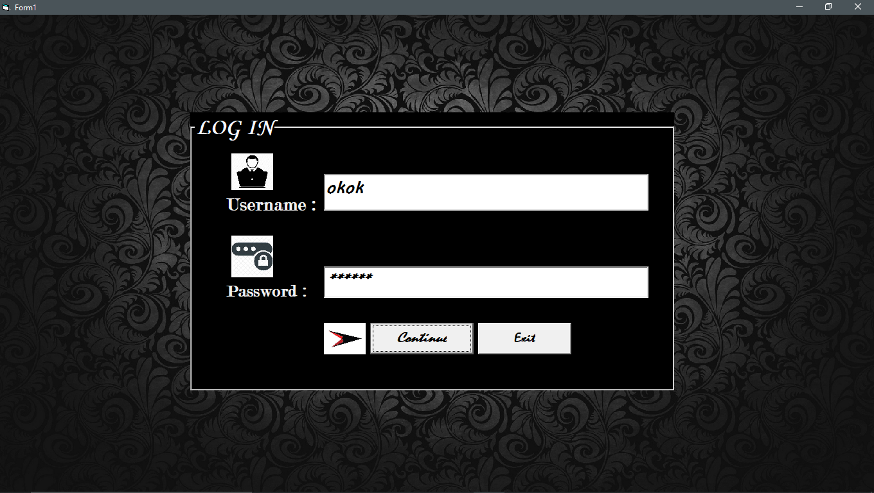

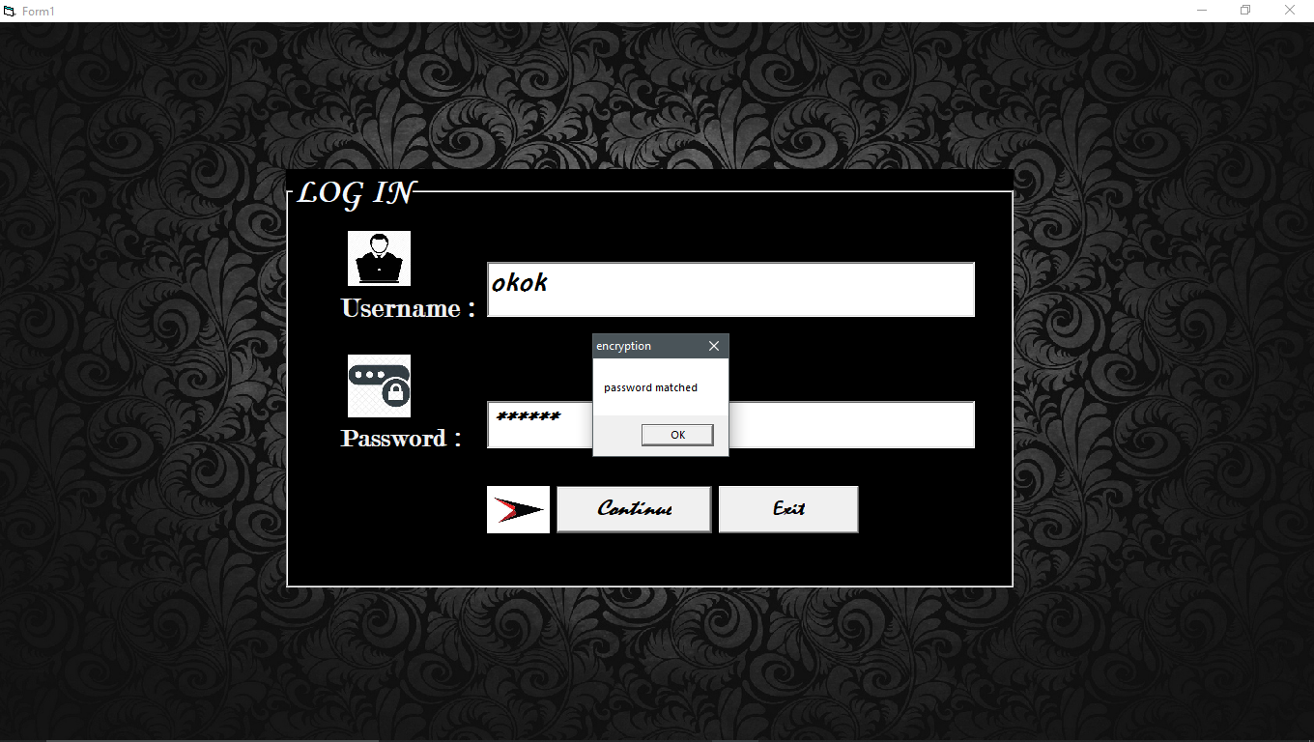

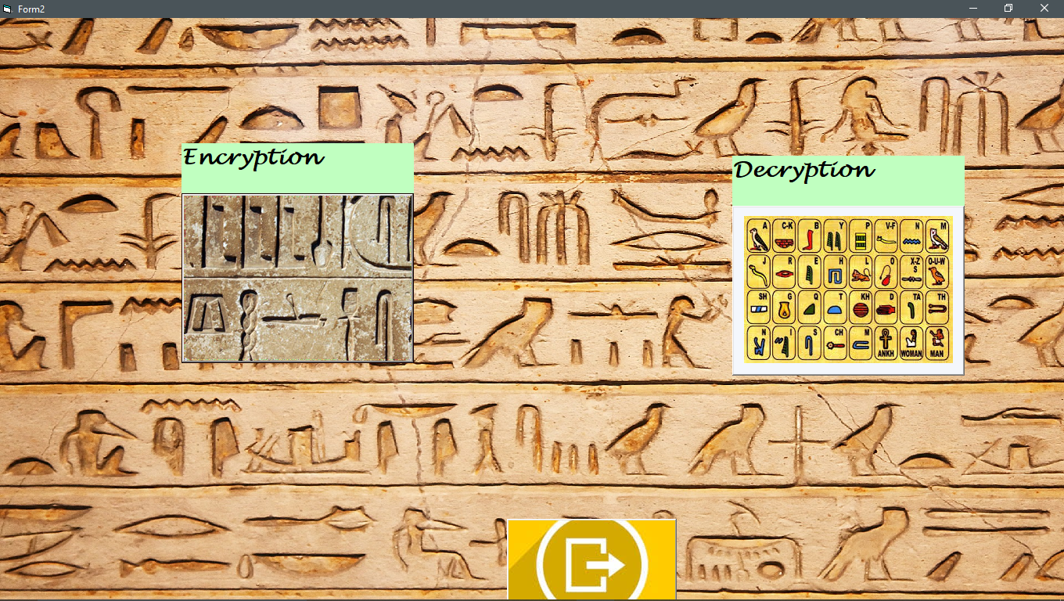

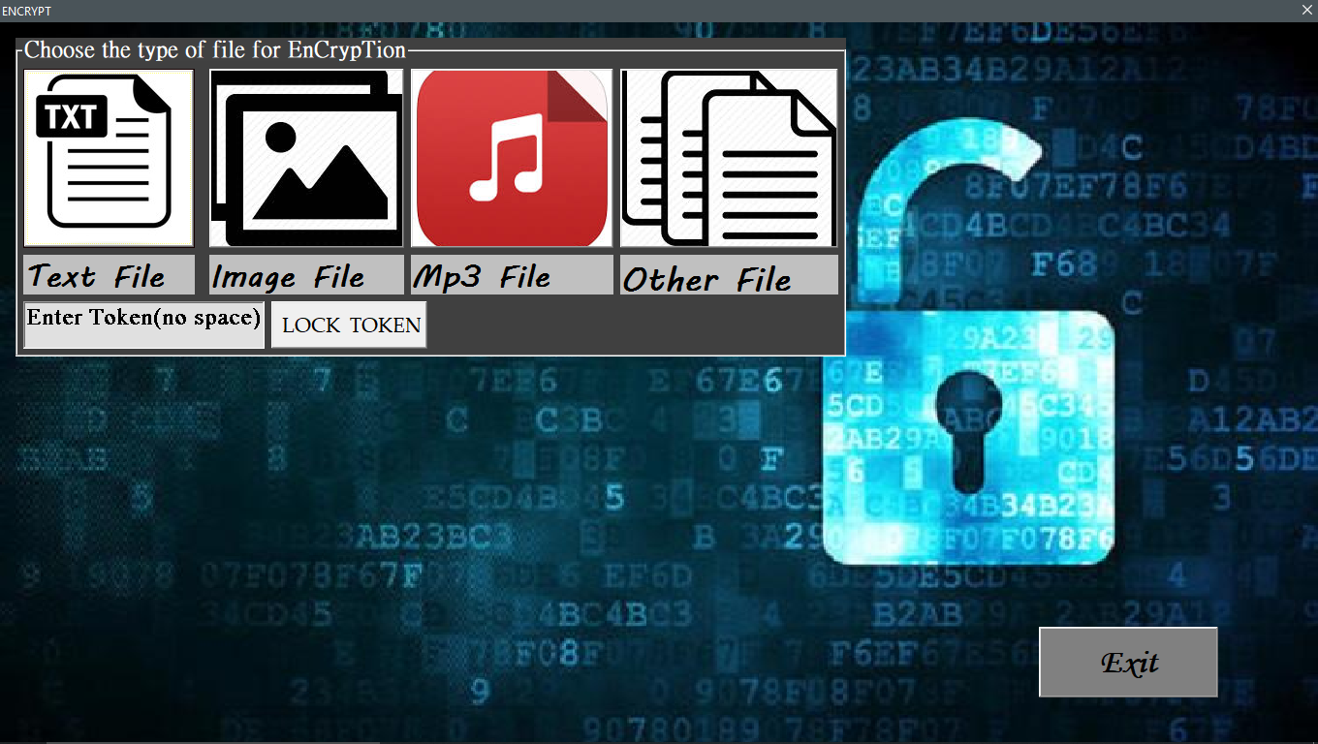

[ Entering a token and clicking on the lock token ]

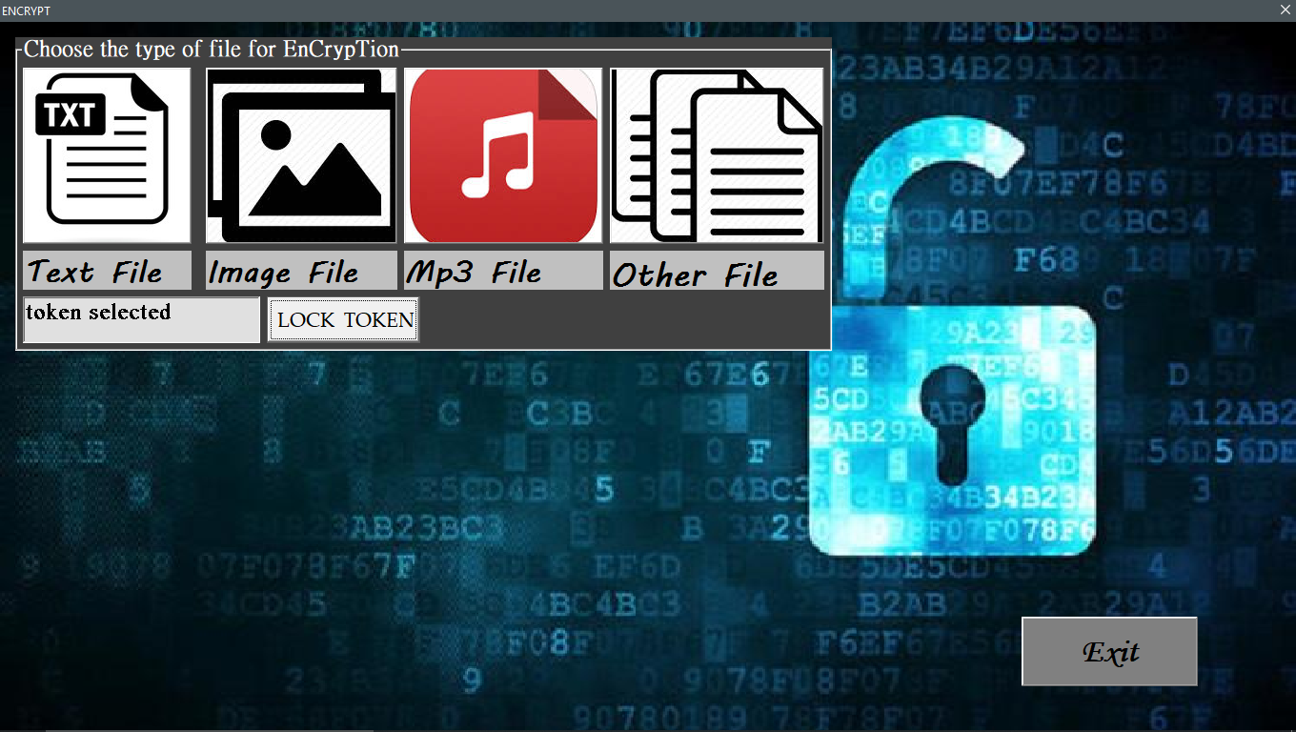

[Token is locked and asking to select file in the next silde ]

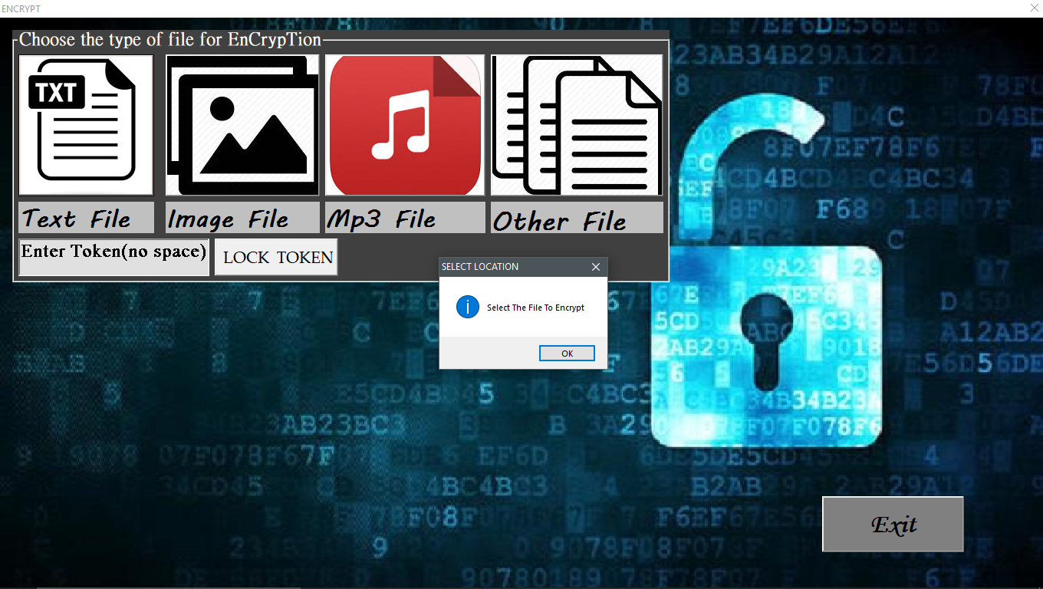

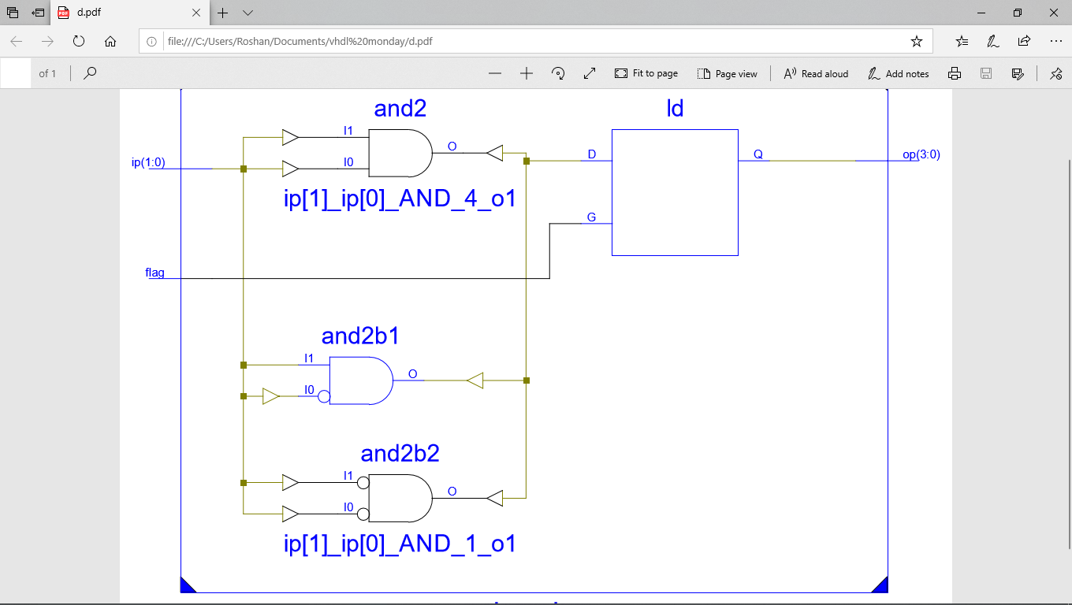

[ the file which is selected for encryption ]

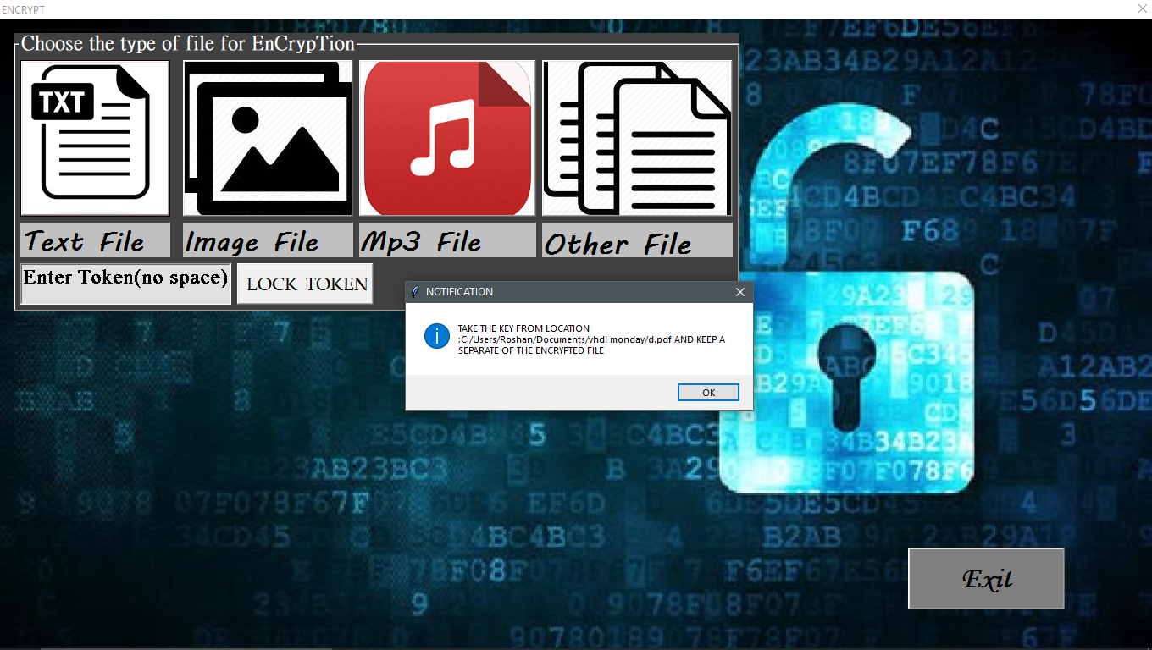

[shows that location of the key generated in 2nd encryption layer ]

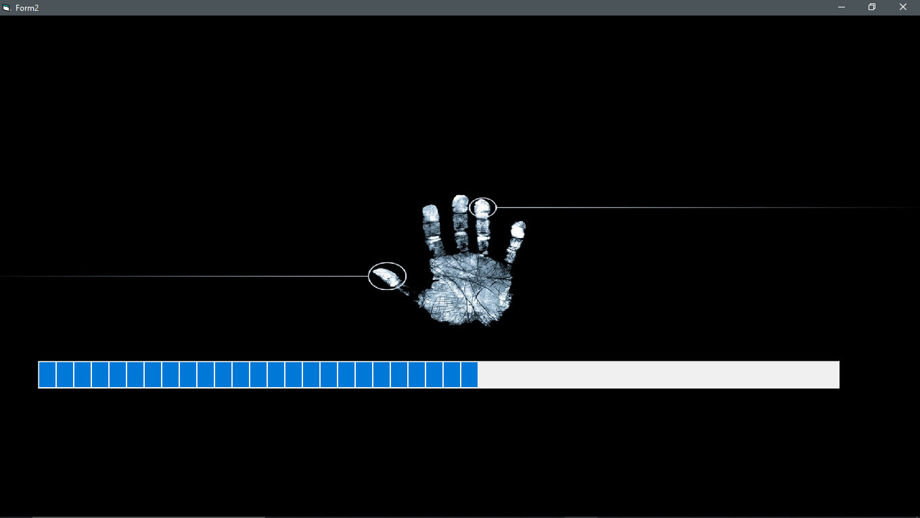

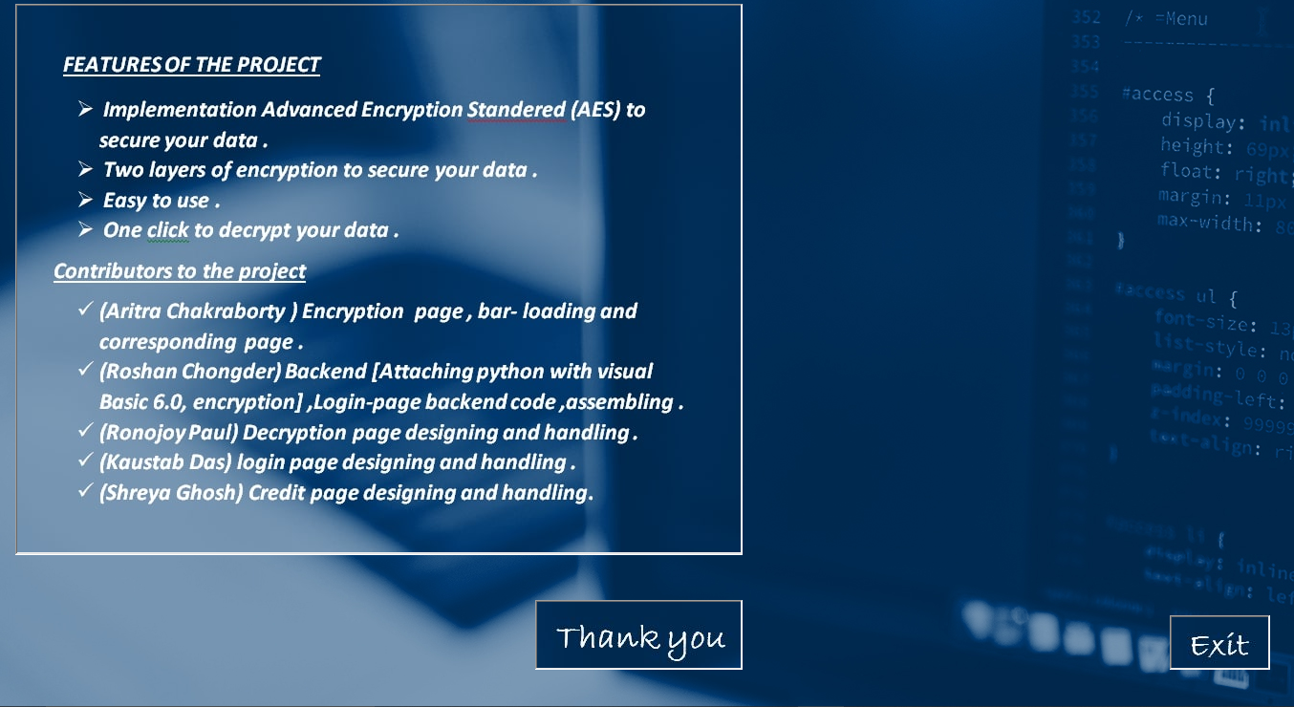

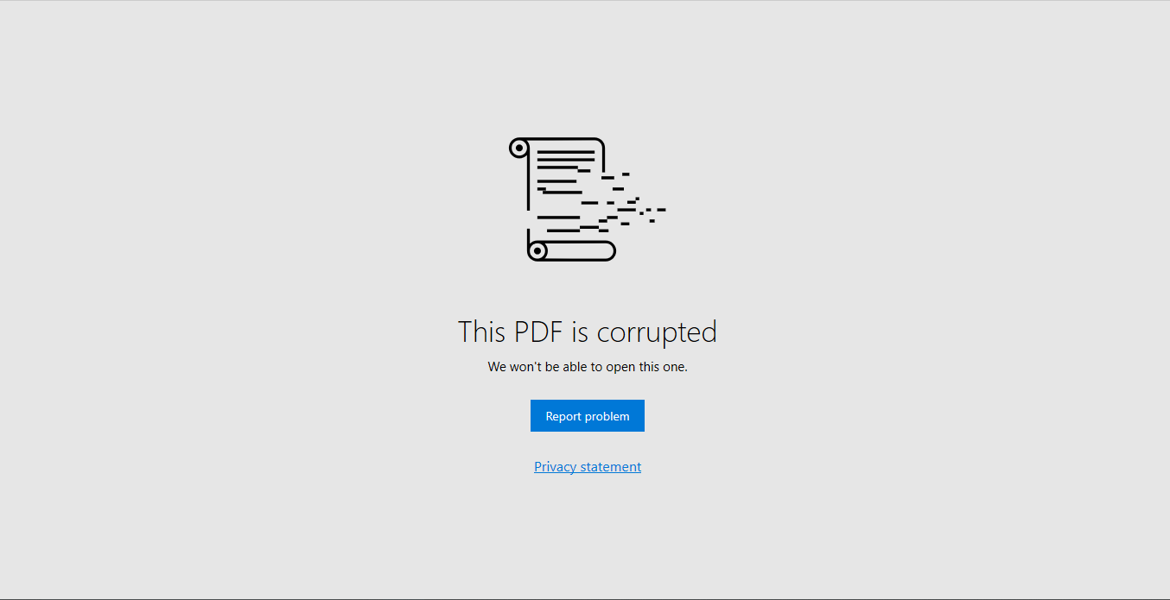

[Pdf is not opening as it is encrypted. Again launching for decryption(next slide)]



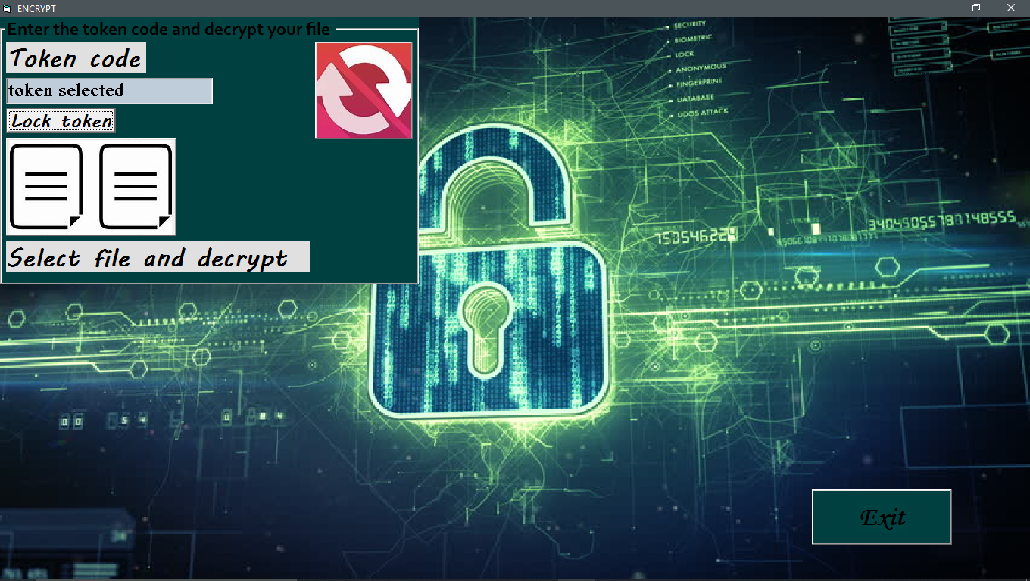

[ Decryption page , giving the same token and selecting key (given) and file ]

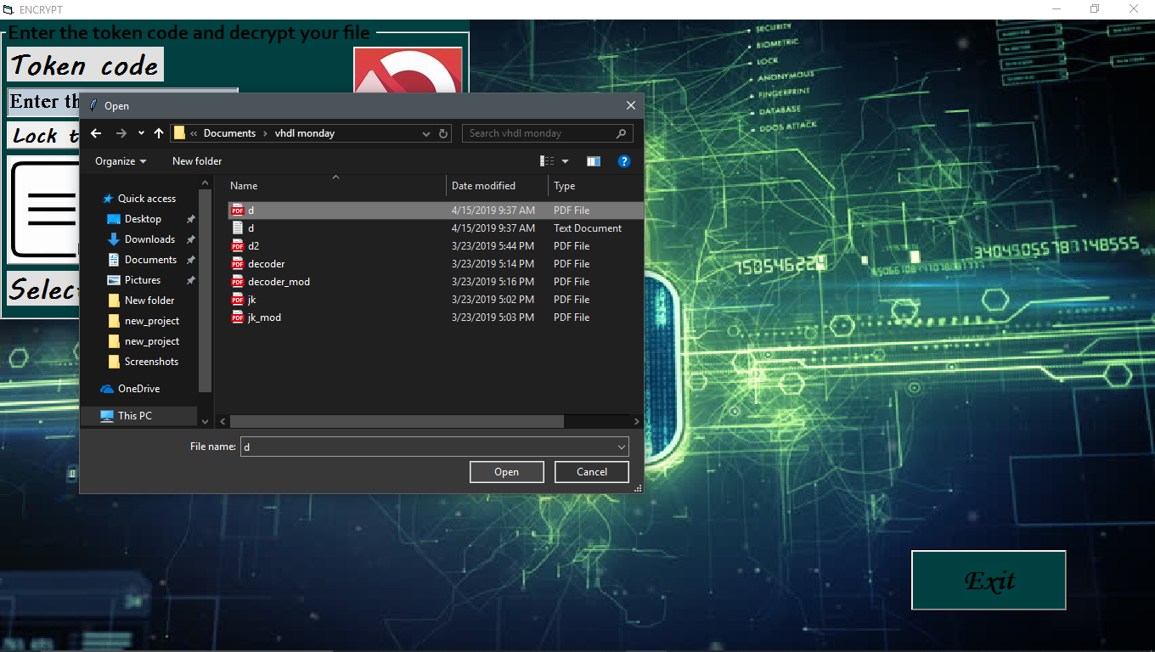

[selecting the file to decrypt ]

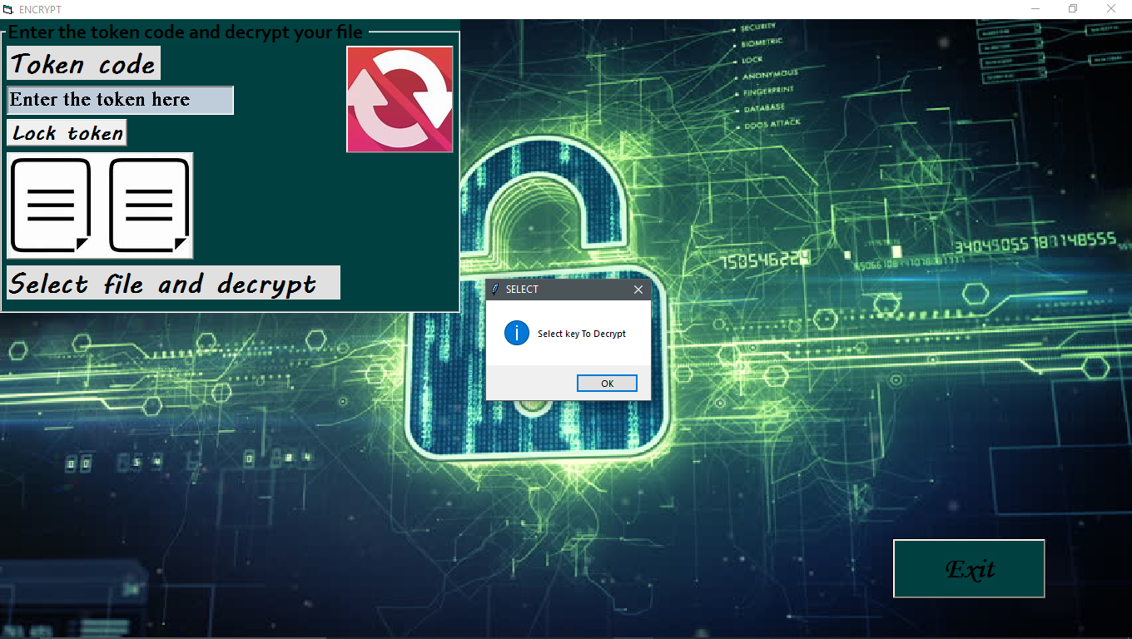

[selecting the key to decrypt]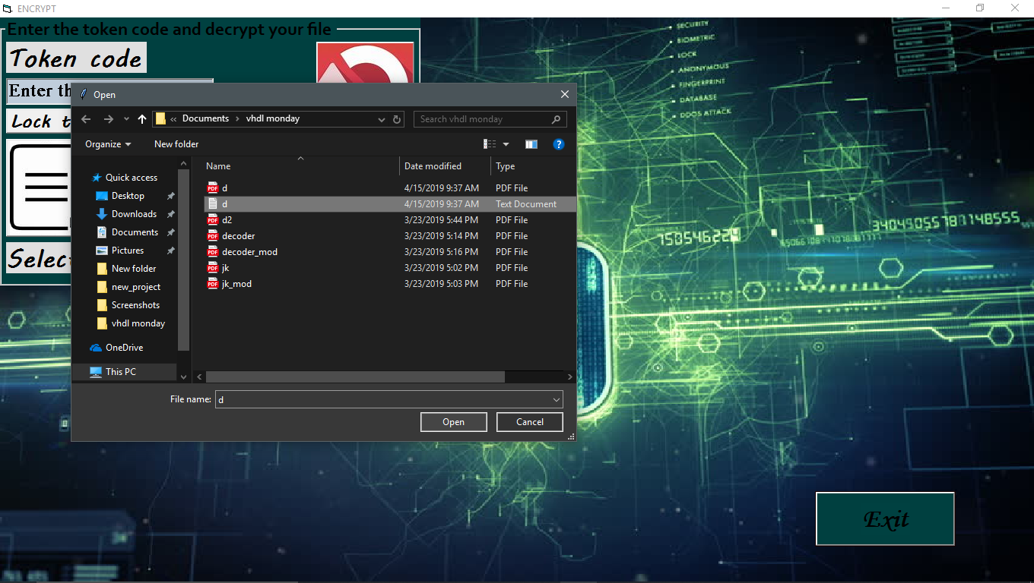

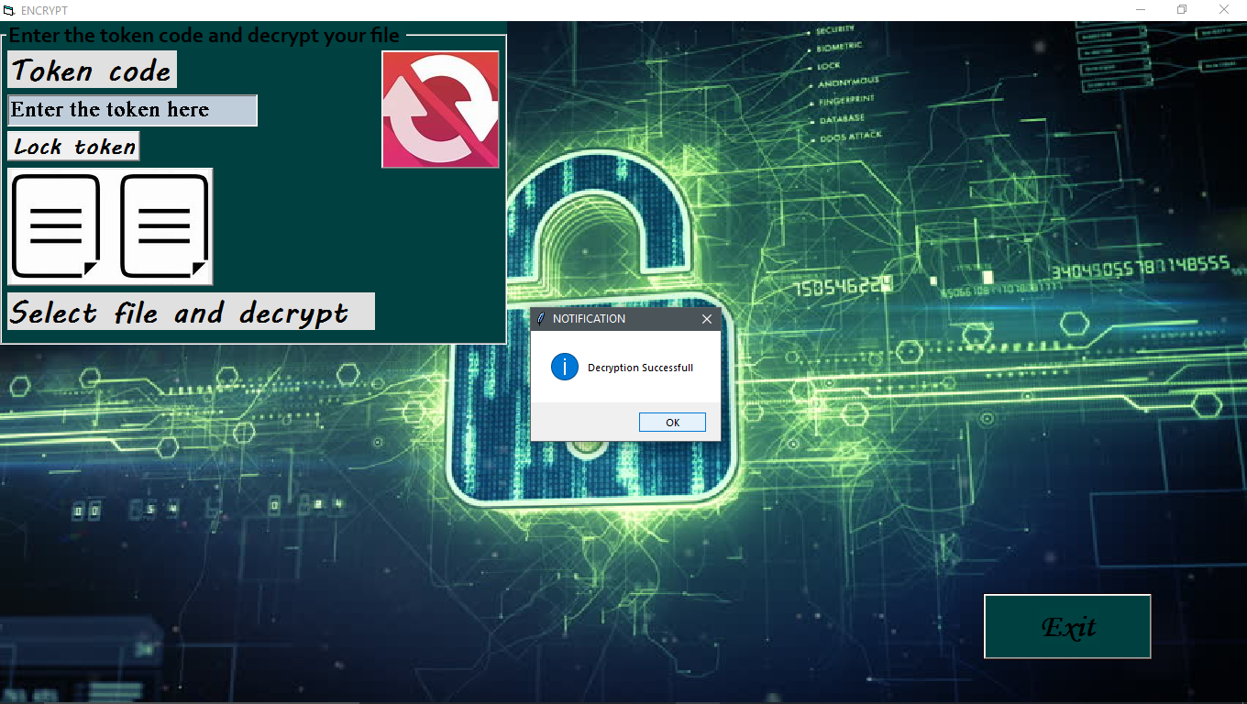

[ successful decryption ]

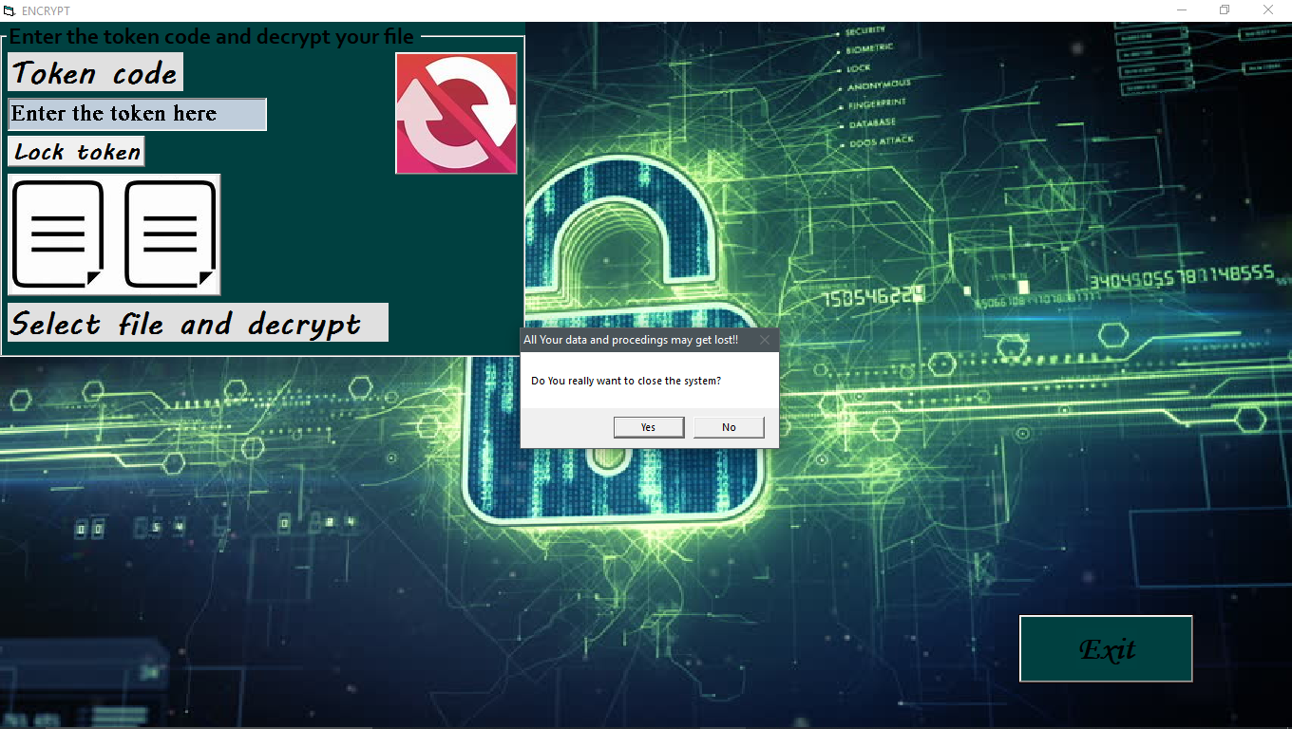



[Ending page ]

[ File is successfully decrypted ]

To check out python code and other stuff , please visit the given link =

https://github.com/RoshanChongder/encryption_decryption_uisng_python3_and_vb6.git